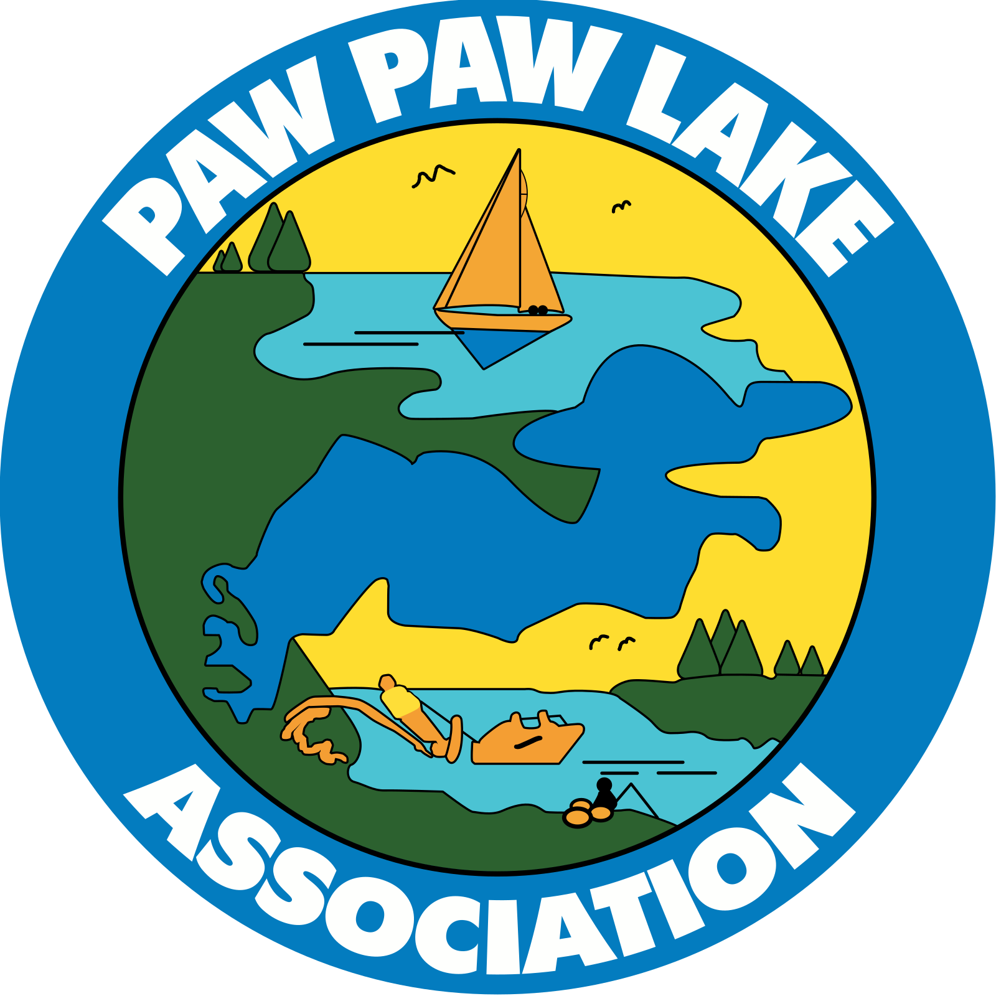
Greetings Paw Paw Lake (PPL) riparian owners. This annual letter aims to define the three organizations serving PPL’s riparian owners and briefly describe their purpose and activities. Getting started:

The Paw Paw Lake Association (PPLA) serves as a representative body for property owners who hold deeded rights to Paw Paw Lake's shoreline. Everyone who owns riparian property is automatically a member of the Association. The Association is committed to addressing matters related to the overall welfare and health of Paw Paw Lake, including, but not limited to, maintaining the water quality of the Lake and its watershed. The Association plans and executes programs designed to enhance and maintain the water and watershed quality and to educate the community regarding lake issues, interact with government at all levels and other organizations regarding lake concerns and issues. It encourages safe lake use and supports recreational activities like swimming, boating, and fishing, all in line with sound environmental practices. Nine directors oversee the activities of the Association. Board members serve staggered three-year terms, and Riparian owners can seek board positions at the Annual Meeting.

The Paw Paw Lake Foundation (PPLF) is a philanthropic organization that receives and manages donated funds to preserve and improve Paw Paw Lake and its ecosystem. It also supports education and public welfare related to these efforts. A board of directors, comprised of members from the public dedicated to advancing the Foundation’s mission oversee Foundation projects. The PPLF board appoints directors that serve without a fixed term limit. Normally, the Board of Directors consists of approximately 17 members, and any vacancies are filled by a Board vote whenever necessary. Donors to the Foundation are extremely generous and the board does an excellent job allocating donated funds. Initiatives such as buying properties that previously contributed nutrients to the lake have now become conservancies significantly reducing nutrient inputs to the lake. Moreover, resources have been allocated to support a Bio-Char Bag initiative, which aims to capture nutrients that contribute to algae growth. Everyone who cares about improving Paw Paw Lake's environment should support the Foundation.

The SAD is a Special Assessment District of Paw Paw Lake Riparian property owners. Coloma and Watervliet Townships collect the assessments through the tax bill. Each year, townships collect assessments totaling about $195,000 used to support ecological management of Paw Paw Lake and its watershed. The SAD is normally reauthorized with a vote by the township boards every four years, with the most recent renewal about two years ago. The next public comment hearing for SAD reauthorization will be in mid-2028.
Since the Paw Paw Lake Association (PPLA) represents the riparian property owners who collectively fund the SAD activities, it is our desire to have PPLA board members from Watervliet and Coloma to become members of the SAD committee. The SAD committee manages SAD spending programs, and we believe the riparian property owners should have a voice on how their special assessment dollars are allocated for lake maintenance and enhancement. It is customary practice at other Michigan lakes to authorize the Lake Association as the deciding authority for assessment spending on lake management programs. The PPLA seeks committee representation in future SAD decision-making.
Page 1 of 2

www.ppla.today
Thank you!
The Paw Paw Lake Association Board

Greetings Paw Paw Lake Association Members!

April 2026

P.O. Box 206

Watervliet, MI

49098

Charlie Pater
President
269 208 1451

Ed Kurasz
Vice-President

Bob Orsi

Treasurer

Rick Hoffmann
Secretary

Ron Roman

Director

John Gibson
Director

Tad Wefel

Director

Kent Walczak
Director

George Schubkegel
Director

The PPLA has worked to improve riparian property owner awareness via enhanced websites, mailers, emails and communicating the time and place of monthly PPLA meetings at which you can provide your feedback or concerns on lake management and activities. The monthly meetings are open to the public and offer time for a wide range of discussion topics. Check our website www.PPLA.today for specific information.

The Paw Paw Lake Foundation (PPLF) has taken a giant step to mitigate nutrient pollution in the lake by acquiring and decommissioning the largest polluting agricultural operation within the watershed, as well as providing management and financial support for the Bio-Char program. The PPLA supports the PPLF and has become more engaged with their projects such as BioChar. PPLA Board members will serve as block captains, informing riparian property owners and distributing Bio-Char bags for installation, offering help if needed. This demonstrates our intention to be a working partner with other organizations focused on Paw Paw Lake improvement.

Paw Paw Lake has experienced accelerated eutrophication (aging process) for the last 60 years and needs a comprehensive long-term plan, 5 to 8 years, to reverse its aging process. Naturally reversing the aging process is possible with newer technologies like oxygenation of the bottomlands which promotes natural breakdown of organic materials. Oxygenation programs have produced favorable results in other lakes within only two to four months. For the past sixty years, Paw Paw Lake has suffered from the harmful effects of excessive chemical use. Now is a perfect time, especially with ongoing Foundation projects to continue with natural means to reverse the aging process of our lake.
The Association Board will keep supporting improvements to Paw Paw Lake's environment, safety, and recreational enjoyment. Your continued support enables us to advance these initiatives. You can join the conversation and share your thoughts at
www.PPLA.today.

Sincerely,

The Association Board of Directors

P.S. We are planning to communicate via email. Your email will be used ONLY for PPLA updates.

Page 2 of 2

www.ppla.today
Thank you!
The Paw Paw Lake Association Board

