PAW PAW LAKE ASSOCIATION
MEMBERSHIP INFORMATION

Please Return form to
Paw Paw Lake Association, Inc.
P.O. Box 206
Watervliet, MI 49098

Name _____________________________________________________
Mailing Address _____________________________________________
City _______________________ State ___________ ZIP ____________

Lake Address _______________________________________________
City _______________________ State ___________ ZIP ____________

Phone _______________________ Cell _________________________
Email _____________________________________________________
Your email will not be sold or given outside of the PPLA.

Donations
All donations are greatly appreciated and help pay for the operating and administrative costs of the PPLA. Donations of $50 or more and return of this form will provide you with a one-year subscription to the Riparian Magazine.
General Fund $__________
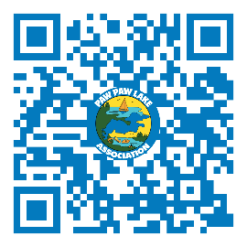
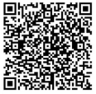
Cash/check
Make Checks Payable to the “PPLA”

PayPal

Zelle

Legal Fund $____________
Total $________________
Donations to the Legal Fund are used only for the PPLA legal expenses.

